**DAILY ONLINE ACTIVITIES SUMMARY**

|  |  |  |  |  |  |  |  |
| --- | --- | --- | --- | --- | --- | --- | --- |
| **Date:** | 08-06-2020 | | | | **Name:** | Gudugunti Anirudh | |
| **Sem & Sec** | IV - A | | | | **USN:** | 4AL18CS023 | |
| **Online Test Summary** | | | | | | | |
| **Subject** | | | Complex analysis, probability and statistical methods | | --- | | | | | | |
| **Max. Marks** | | 30 | | **Score** | | 18 | |
| **Certification Course Summary** | | | | | | | |
| **Course** | **Data structures and algorithms in c++** | | | | | | |
| **Certificate Provider** | | | Udemy | **Duration** | | | **2.5 hr** |
| **Coding Challenges** | | | | | | | |
| **Problem Statement:**1: Program to sort an array having only 0s, 1s and 2s . | | | | | | | |
| **Status:** completed | | | | | | | |
| **Uploaded the report in Github** | | | | yes | | | |
| **If yes Repository name** | | | | https://github.com/alvas-education-foundation/anirudh_gudugunti/tree/master/daily_progress | | | |
| **Uploaded the report in slack** | | | | yes | | | |

Online Test Details: (Attach the snapshot and briefly write the report for the same)

Certification Course Details: (Attach the snapshot and briefly write the report for the same)

Coding Challenges Details: (Attach the snapshot and briefly write the report for the same)

**Online Test Details:** It was about the topic from module 2. The questions were all multiple-choice questions which were optimal and easy to solve. The score that I got was 18/30.

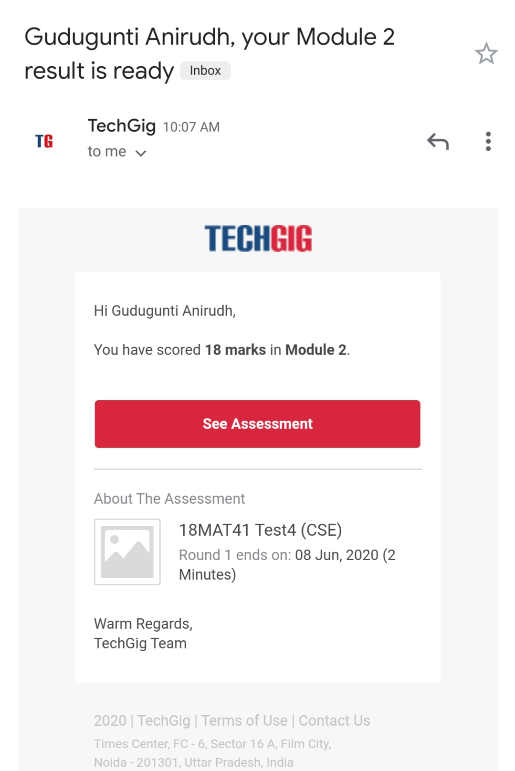

Snapshot of certification course:

1. Introduction to arrays in data structures.

2. Insertion and Deletion of elements in an array.

3. Some examples on arrays with neat diagrams.

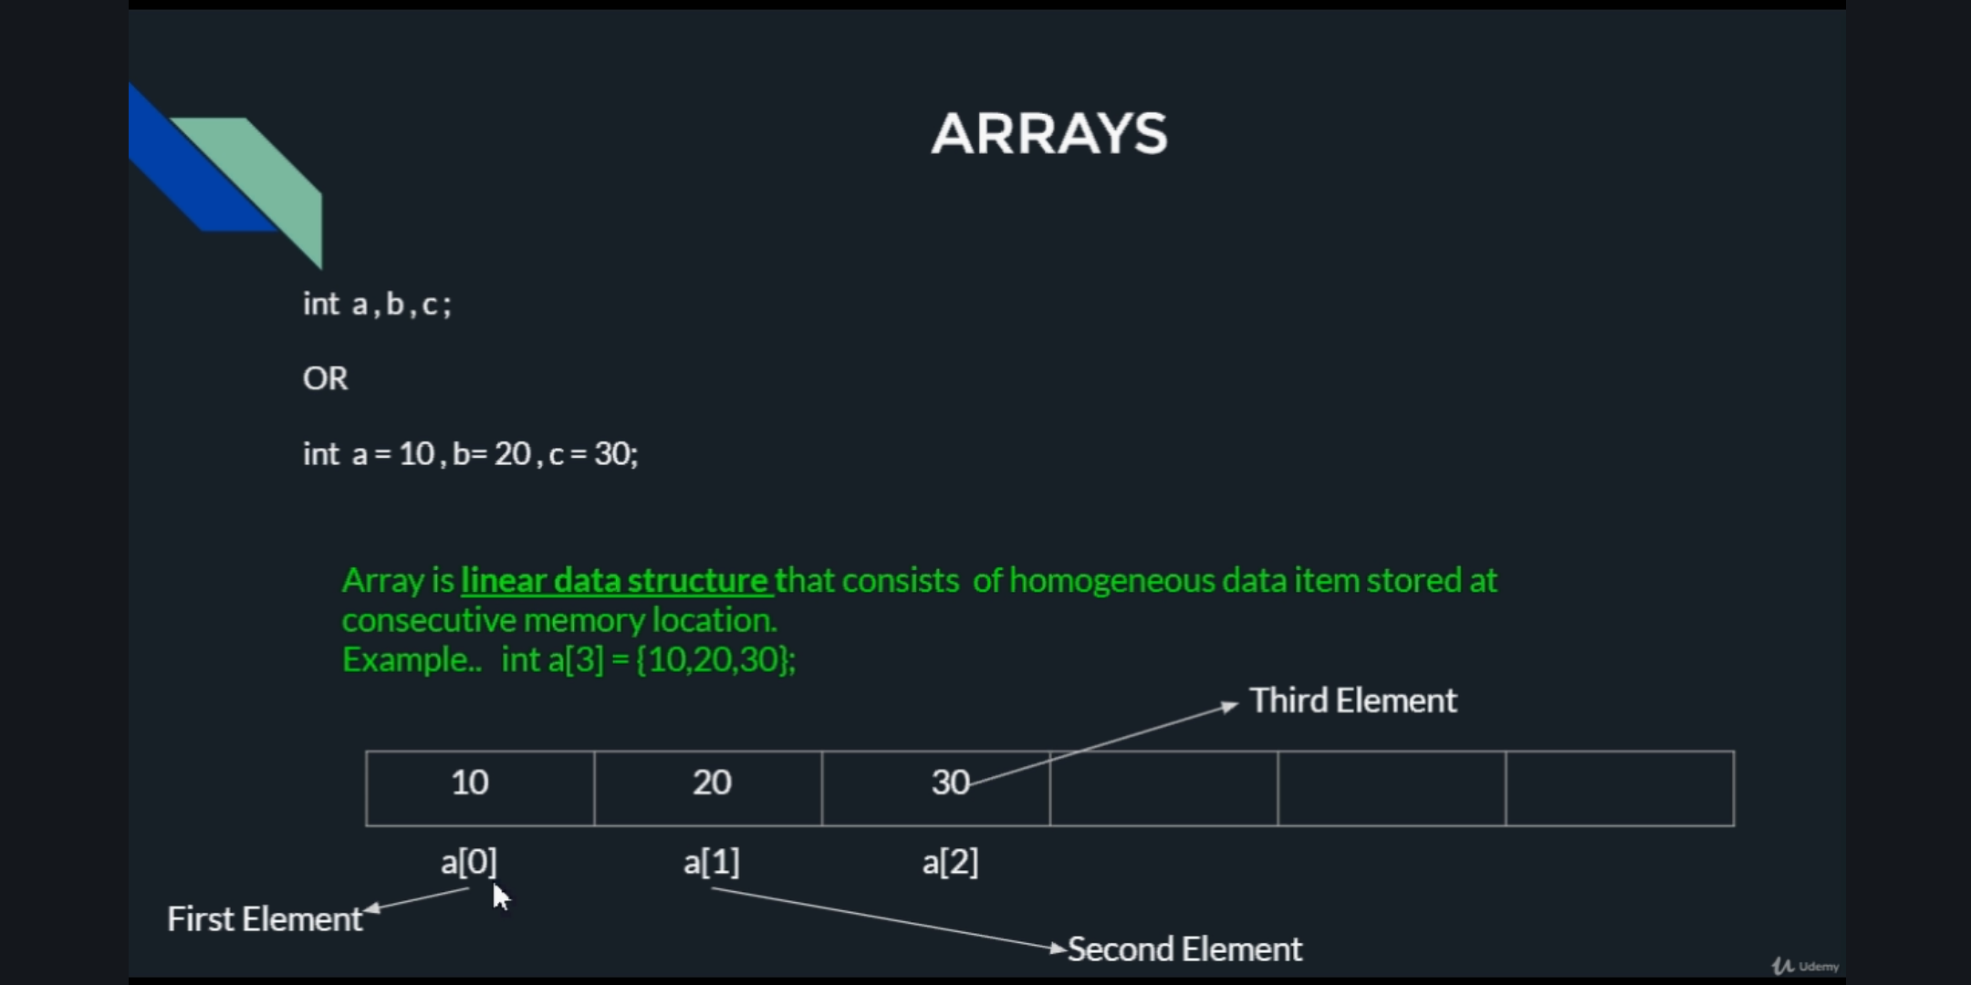

**Online coding:**

Problem 1: (using java) program to sort an array having only 0s, 1s and 2s.

